Molecular Reactions

Play Area Design
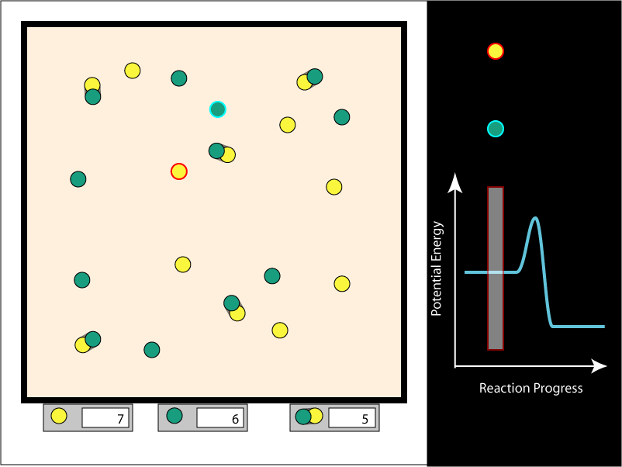

Physical Panel
The left portion will, for the purposes of this discussion, be called the physical panel. It shows green and yellow molecules bouncing around in a reaction box. If one of each type hit each other with sufficient energy, they form a new, combined molecule that has the proper combined linear and angular momentum. If they do not collide with enough energy, they will rebound.
The user will be able to select a single molecule in the physical panel to track in the Reaction coordinates panel (see below). The selected molecule is highlighted with a red border so the user can track it visually. The molecule of the other type nearest to the selected molecule is automatically highlighted in a contrasting color. As the molecules move around in the box, the molecule that gets this second highlight will often change.
The left portion of the play area will have readouts for the number of each type of molecule in the box. The number will be editable by the user.
There will be a readout of some sort for the temperature in the box. The user will be able to change the temperature in the box. Just how this will be controlled, and the graphical representation for the source of heat and cold has not be decided. We may use the graphical components from the Gas Properties simulation.

Reaction Coordinates Panel
The right portion of the play area will, for the purposes of this discussion, be called the Reaction coordinates panel. It shows a representation of the potential energy of a single molecule in the upper area. The curve shows the potential energy of the user-selected molecule as it gets closer to single molecules of the other type, and as it collides and merges with them.
The vertical bar is a cursor that moves left and right as the distance changes between the user-selected molecule and the closest molecule of the other type.
The molecule representations near the top of the panel correspond to the user-selected molecule (the icon with the red outline) and the molecule of the opposite type that it closest to it (the icon with the cyan outline). As the two molecules they represent in the physical panel move closer together or farther apart, the cursor bar will move right and left in the Reaction coordinates panel, and the two icons above the cursor bar will move closer or farther apart. If they get merge into a single molecule in the physical panel, the cursor will go over the hump of the curve, and the icon will turn into one similar to the one for the merged molecule in the physical panel. The user will be able to manipulate the potential surface with the mouse. The peak of the curve will be movable up and down, as will the level parts of the surface to the left and right of the curve.

Scrollable Strip Chart
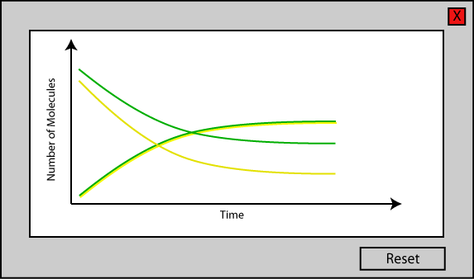
The simulation will have a panel that shows the numbers of each type of molecule in the box over time. It will only be displayed in Panel 3 of the top level panels (see below). The information will be presented as a scrollable strip chart. When the simulation is paused, the user will be able to scroll back and forth in time through the information.

Other Controls
In addition to the standard play, pause, and step controls, there will be a standard stopwatch.

Top-Level Panels
Currently, three top-level tabbed panels are envisioned. Unimolecular reactions will be designed later, and will either be on another panel, or another simulation entirely.

Panel 1
The reaction box will have two molecules in it: one of each type. Its purpose is to let the user see what happens when two molecules collide. In addition to letting the clock drive the model, there will be a mode in which the user can drive the model by moving the cursor bar on the Reaction coordinates panel left and right.

Panel 2
The user will be able to control the number of molecules of each type with the controls at the bottom of the physical panel, and the temperature of the system. The user will not be able to control the cursor bar in the Reaction coordinates panel.

Panel 3
This will be similar to Panel 2, with the addition of the scrollable strip chart.

Notes on the Model
For the purposes of this discussion, I will refer to the product of two molecules that combine to for a larger molecule as a composite molecule. The distance between the components of a composite molecule will vary with time, according to some probabilistic function, yet to be defined. The varying distance will be reflected in the graphics that represent the molecules. As that distance varies, the cursor in the Reaction Coordinates panel will move left and right accordingly.

